IKU-SPECTRA INTERNATIONAL CONGRESS ON SPECTROSCOPY (ICS 2026)
Abstract Template
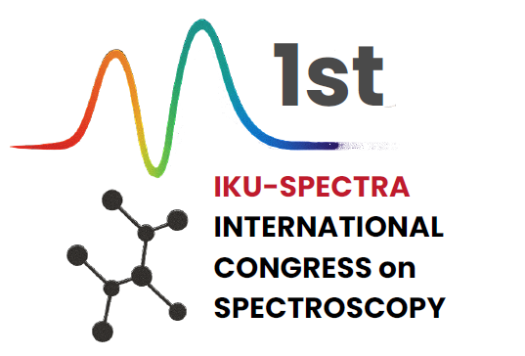

Title of the Abstract
First Author¹, Second Author², …, Last Authorⁿ
¹Affiliation, Department, University, City, Country
²Affiliation, Department, University, City, Country
Corresponding author: corresponding.author@email.com

Abstract: The abstract should briefly describe the purpose of the study, methods used, major findings, and conclusions. Please avoid changing the document’s layout, margins, or styles. Abstracts must be written in English and should not exceed one page in total, including figures, tables, and references. Figures and tables should be centered and numbered in the order they appear in the text.

Figure 1. Figure caption (Times New Roman, 10 pt, Centered)

References
1. A. Author, B. Author, J. Spectrosc. Sci., 2 (2024) 320.
2. C. Author, Journal Name, Vol. (Year), First page.
Acknowledgements:
The authors gratefully acknowledge the support of [Funding Agency / Project Name, if applicable].
File name: ICS2026_Abstract_LastName.docx
Abstracts should be submitted via the congress website or by e-mail to ics2026@iku.edu.tr

